**IT17157674 – V.Aperame**

**MLCS (Machine Learning for Cyber Security)**

**User Manual - Price Prediction for Real Estate**

**All the codes including for the Machine Learning Model as well as the code written for web application/ web page development are presented in GitHub.**

To test the build model and project in the Localhost, for this, In PyCharm first the user need to run the “server.py” in order to up the server. Next, the user need to run the “app.html”. PyCharm is a community edition. So the user need to download it for free and need to install it in the PC (Personal Computer). And the version the user need to use is 2019.3.3. Also it is a Python editor. Rather than this, the user also need to import the Python Flask Server as well as need to install the Python.

Finally, in order to run the website, the user need to click the “Google Chrome” icon which is presented in the right hand corner side, in the “app.html” in PyCharm. (Figure 1) shows it.

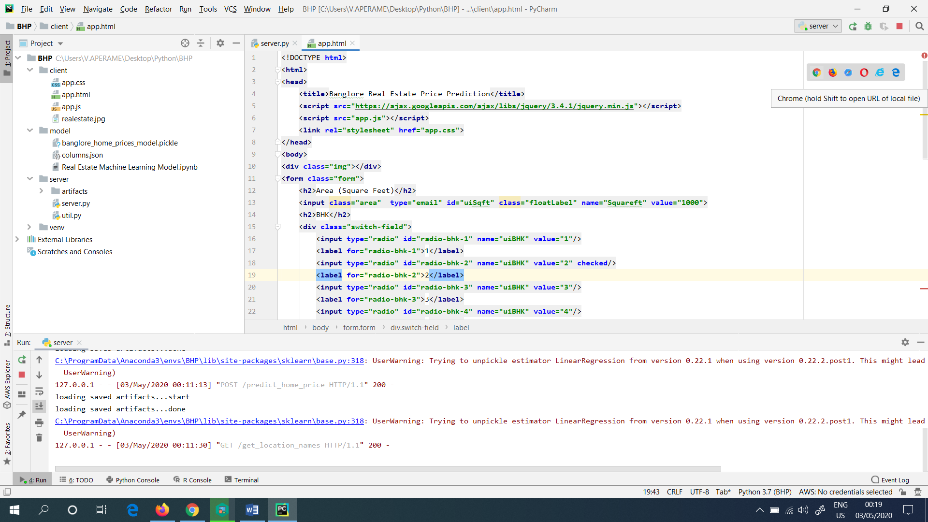

Figure 1: Clicked the Google Chrome icon in “app.html” file

**OR**

**There is another method (Second Method) presented, in order to run the project. This is explained below.**

The user directly goes to the “app.html” file, which is presented in the PC (Also in GitHub), and need to double click it in the file. This procedure also prompts the user, for a similar website which showed below. This is shown in (Figure 2). This is directly hosted in the local host of the PC (Personal Computer).

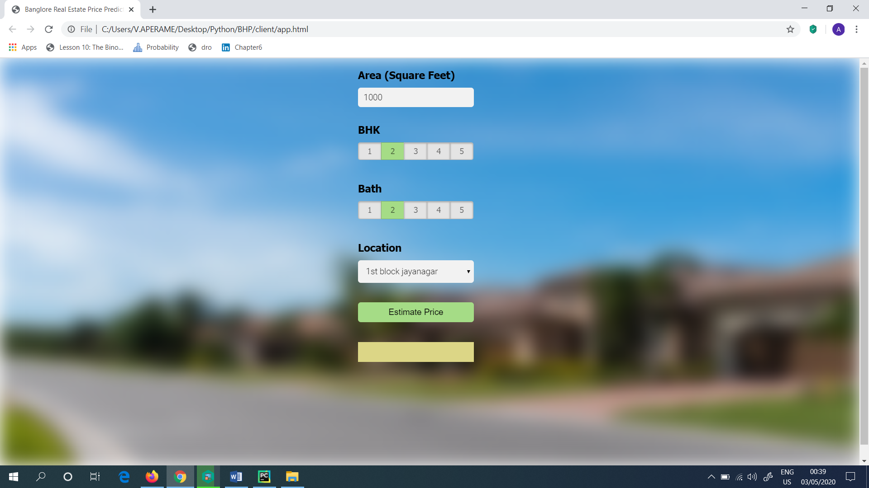

Figure 2: Got the same website by double clicking the “app.html” file

Next, when the user continued from the first method which showed above, suddenly, in the Local host the website which is created will be hosted as shown in (Figure 3). This is hosted with the help of the PyCharm.

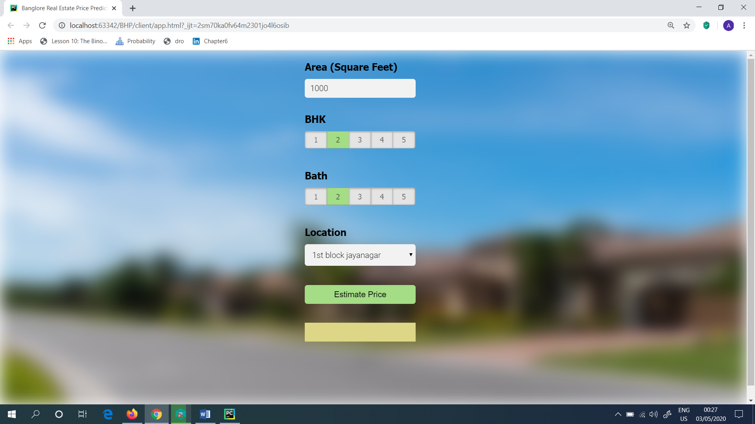

Figure 3: Website hosted in the localhost

Then, the user need to check the model, whether it is working fine or not. So, as the input for the website the user need to give the following as shown in (Figure 4) and it returned the estimated price as 219.14 Indian Lakh Rupees.

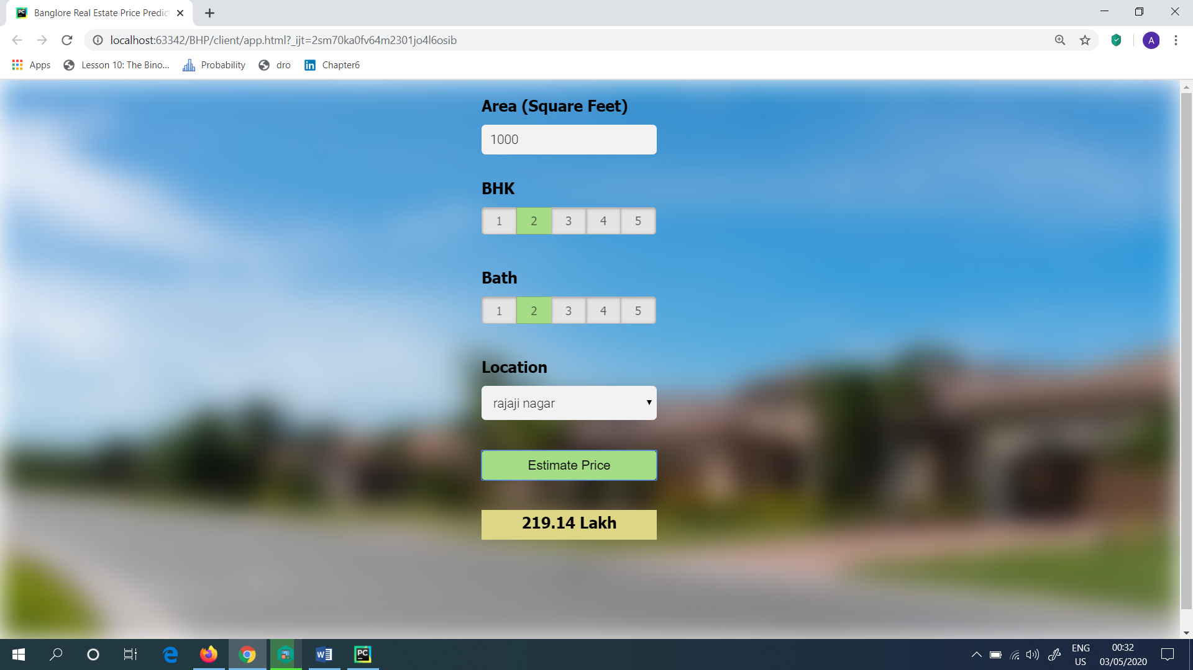

Figure 4: Got the estimated price

Next, the user can also try the Estimated Price by giving different inputs. The model is working fine and right without any errors. The Estimated Price is varying according to the user inputs as well as the Location.